Java Project 2 – Antique Auctions

Unit 6

Donovan van Heerden

EL2014-0043

**Contents:**

* How to add the Database to MS SQL Server 2008
* How to setup the MS SQL Server 2008 Database
* Running the Web Application in Netbeans

**How to add the Database to MS SQL Server 2008:**

* Open Microsoft SQL Server 2008
* Right click on the Database folder and select **Attach…**

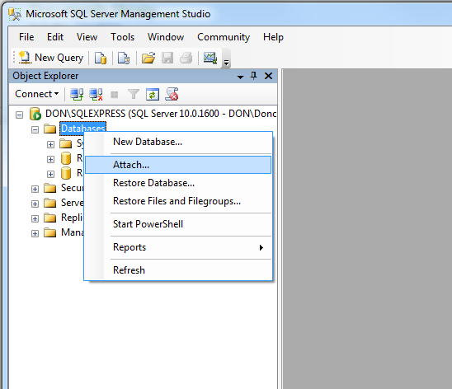

* A new window should appear, click on **Add…** Another new window should appear, now locate the database **.mdf** file and select it, followed by clicking the **OK** button.

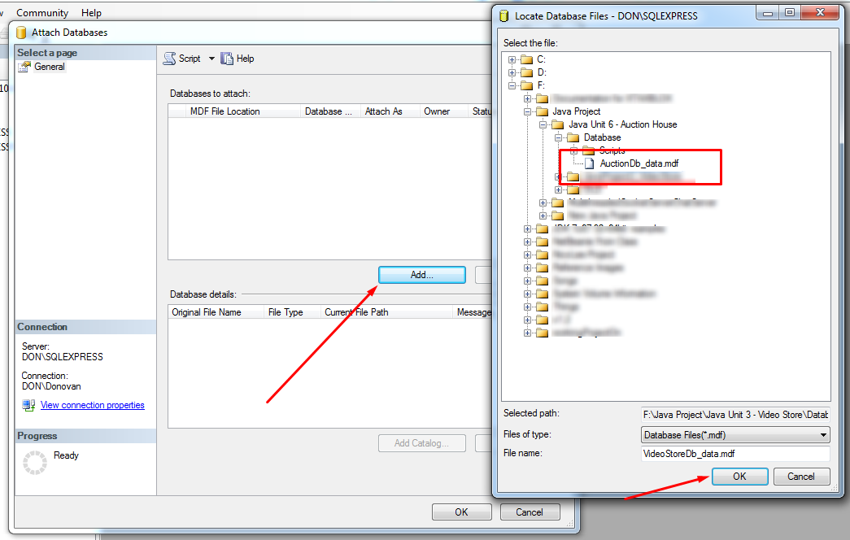

* The previous window should now have some information in it, similar to the image below, now select **OK.**

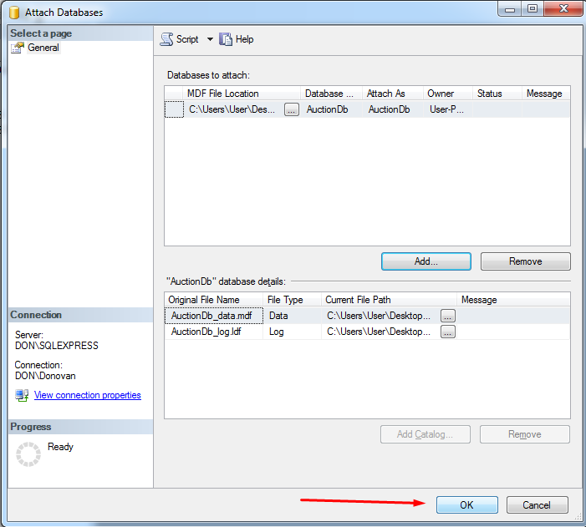

* You should now see the database has been added to the Databases Folder in MS SQL Server.

**How to setup the MS SQL Server 2008 Database:**

Go to **Start > Control Panel > Administrative Tools > ODBC Data Source**.

* Select the **System DSN** tab at the top.
* Click the **Add** button to the right.
* In the list box, select **SQL Server Native Client 10.0** and then click **Finish**.
* Enter **“AuctionDb”** in the **Name** field, **“Auction House Database”** in the **Description** field, and select the name of your **SQL Server** from the combo box.(See image below for example of where to find this information.) Click the **Next** button.

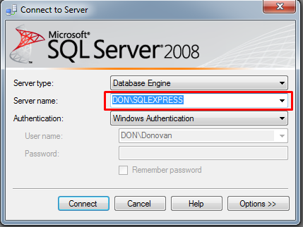

* Make sure the **With Windows NT authentication…**, and the **Connect to SQL Server ….** items are selected. Click the **Next** button.
* Make sure the **Change the default database to…...** box has a tick in it, and select **“AuctionDb”** form the drop-down list. Leave the rest of the checkboxes as they are.
* Click **Next**.
* Click **Finish**.
* A new frame will be displayed showing the chosen settings. Click the **Test Data Source** button to see if you have set it up correctly. It should say ‘Test Completed successfully’. If not, go through the setup again.
* Click **OK**.
* You should see the name of your database in the **System DSN** tab.

**Running the Web Application in Netbeans**

Open Netbeans,

This project requires a **Glassfish Server v 3.1.2** or greater, ensure that Glassfish is installed with Netbeans.

* Click **File** > **Open** **Project** and browse to where the project folder is located.
* Once the project has been loaded into **Netbeans**, right click on the project and click **Deploy**.

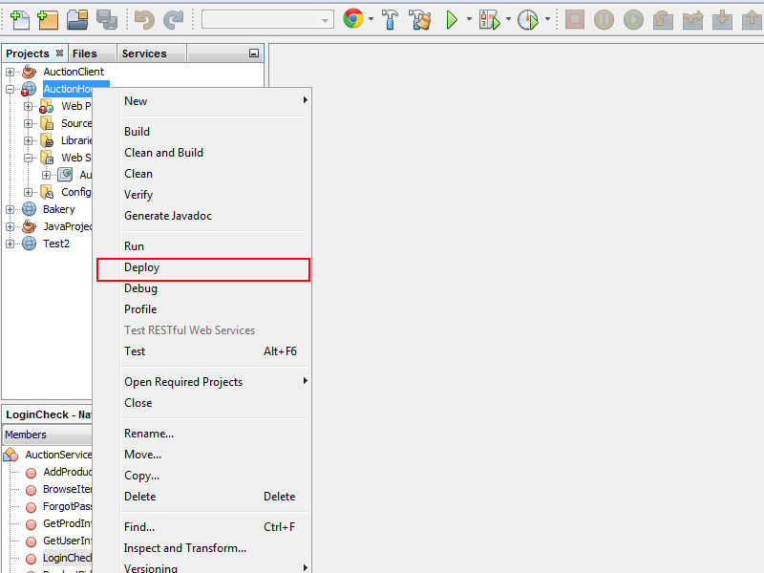

* 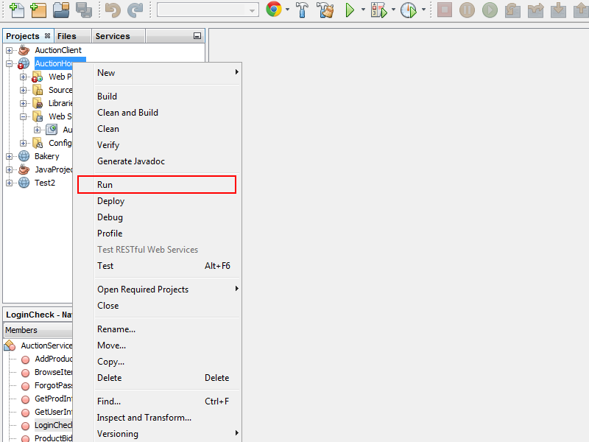Once the deployment process is complete, click **Run**. And it should automatically open your browser with the project.